**DAILY ONLINE ACTIVITIES SUMMARY**

|  |  |  |  |  |  |  |  |  |
| --- | --- | --- | --- | --- | --- | --- | --- | --- |
| **Date:** | **07-06-2020** | | | | | **Name:** | **Deril Quadras** | |
| **Sem & Sec** | **8 A** | | | | | **USN:** | **4AL16CS031** | |
| **Online Test Summary** | | | | | | | | |
| **Subject** | | **-** | | | | | | |
| **Max. Marks** | | **-** | | **Score** | | | **-** | |
| **Certification Course Summary** | | | | | | | | |
| **Course** | **Introduction to Amazon simple queue service.** | | | | | | | |
| **Certificate Provider** | | | **AWS** | | **Duration** | | | **10 mins** |
| **Coding Challenges** | | | | | | | | |
| **Problem Statement:**   1. **Write a program in C to Check Leap Year** | | | | | | | | |
| **Status: Solved** | | | | | | | | |
| **Uploaded the report in Github** | | | | | **Yes** | | | |
| **If yes Repository name** | | | | | **Derilquadras/online_c_coding_repository** | | | |
| **Uploaded the report in slack** | | | | | **Yes** | | | |

Online Test Details:

NOT CONDUCTED

Certification Course Details:

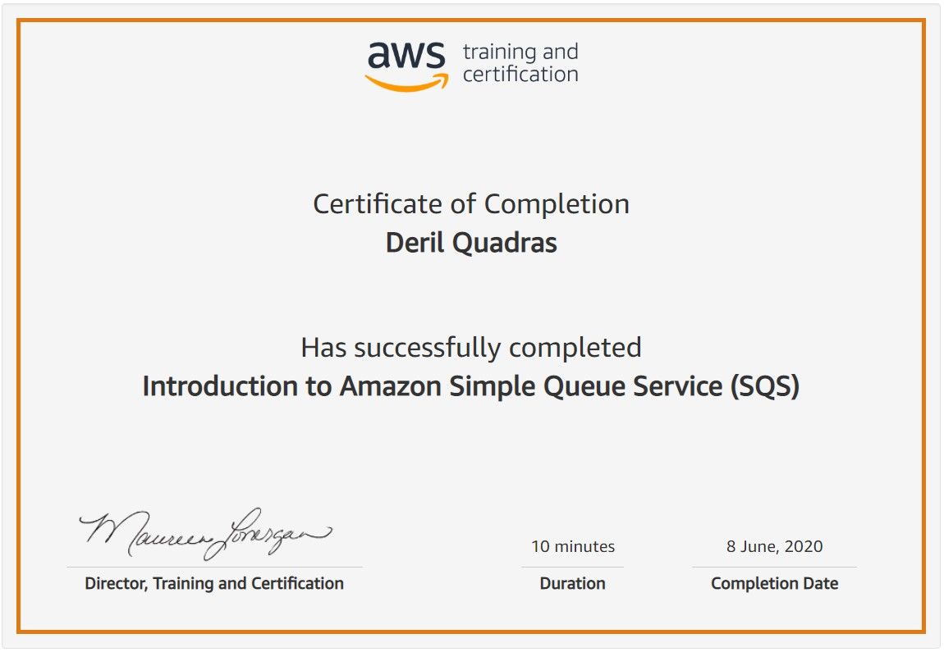

Coding Challenges Details:

**PROGRAM 1 .**

**// Write a program in C to Check Leap Year.**

**#include <stdio.h>**

**int main() {**

**int year;**

**printf("Enter a year: ");**

**scanf("%d", &year);**

**if (year % 400 == 0) {**

**printf("%d is a leap year.", year);**

**}**

**else if (year % 100 == 0) {**

**printf("%d is not a leap year.", year);**

**}**

**else if (year % 4 == 0) {**

**printf("%d is a leap year.", year);**

**}**

**else {**

**printf("%d is not a leap year.", year);**

**}**

**return 0;**

**}**